
Frontend Connect – Web3.js Integration

Objective:
Apparatus/Software Used:

- Laptop/PC
- Node.js and npm
- Visual Studio Code (VS Code)
- MetaMask Wallet
- Web Browser (Chrome / Brave)
- Web3.js Library
- HTML, CSS, JavaScript (Frontend Stack)

To integrate the frontend of a decentralized application (DApp) with the Ethereum blockchain using Web3.js, enabling user interaction with smart contracts through a web interface.

Theory/Concept:

- Web3.js is a JavaScript library that enables web applications to interact with the Ethereum blockchain. It connects the DApp frontend with the blockchain network, allowing users to check balances, send transactions, and interact with smart contracts directly from their browsers.
- Key Concepts:
  - Blockchain Connection:
Web3.js links a frontend application to the Ethereum network through a provider such as MetaMask or a custom RPC endpoint.
  - Account Access:
Users must authorize the DApp to access their blockchain wallet addresses for transactions and contract interactions.
  - Smart Contract Interaction:
JavaScript functions generated from a contract’s ABI (Application Binary Interface) are used to read or write data on the blockchain.
  - Event Listening:
Web3.js can listen to events emitted by smart contracts, allowing real-time updates and dynamic changes within the user interface.



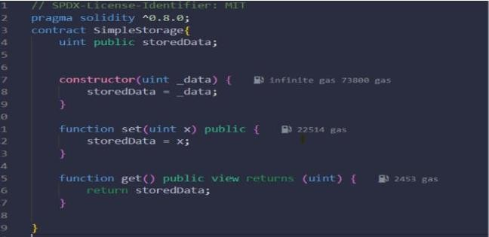
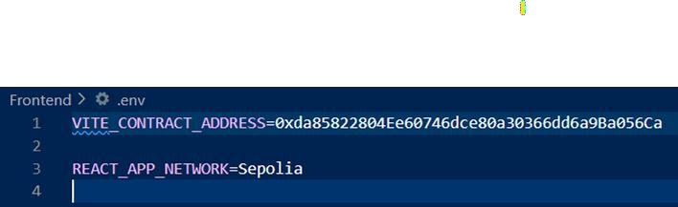
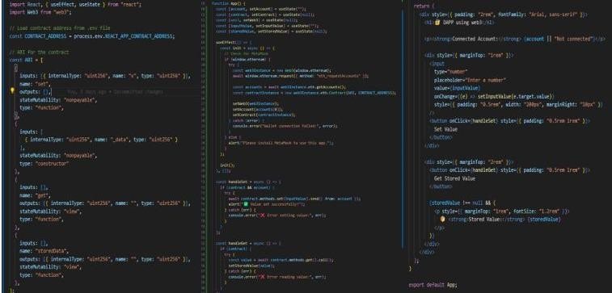
Procedure:
Step:1 Create a smart contract in remix IDE

step 2: Create a React app in VS Code.
- Open VS Code.
- Open a terminal inside of VS Code.
- Run this code (npx create-react-app simple-storage-web3).
- Then run cd simple-storage-web3.
- Then install web3 like run this code(npm install web3).
Step 3: Create a .env File.
- Write The deployed contract address from Remix or blockchain explorer

Step 4: Connect in src/App.js
- Replace App.js with something like:

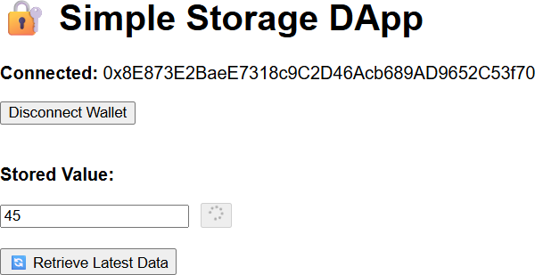
Step 5: Run the App
In terminal: npm start
Step 6: After run this open React app at http://localhost:3000.

Observation :
- Audit tools successfully detected vulnerabilities in the initial contract.
- Common issues included missing access controls and reentrancy risk.
- After applying fixes and best practices, all critical warnings were resolved.

